**TASK 1**

**Q1: Write a program to check if a number is positive, negative or zero**

**PROGRAM**

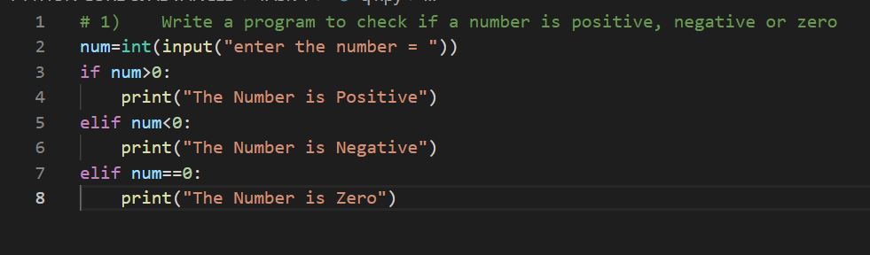

**OUTPUT**

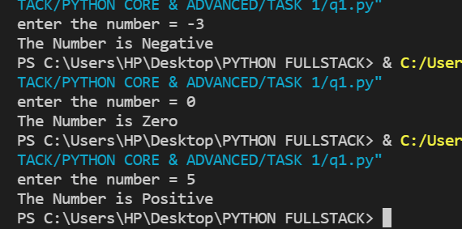

**Q2: Write a program to check if a person is eligible for voting or not   
conditions – age greater than or equal to 18 the person is eligible   
 age less than 18 not eligible for voting**

**PROGRAM**

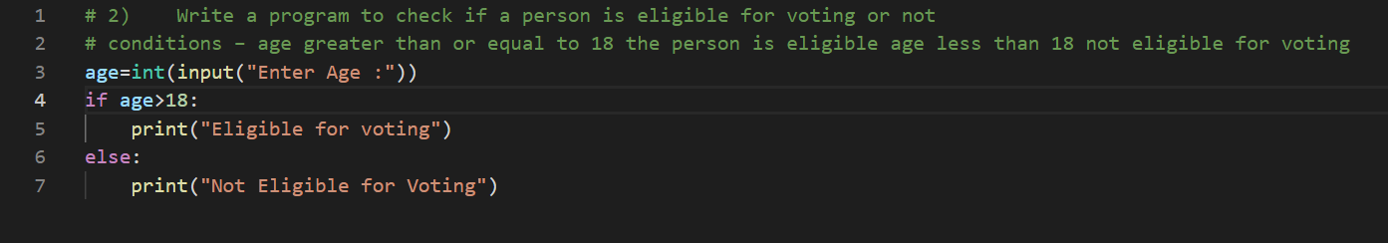

**OUTPUT**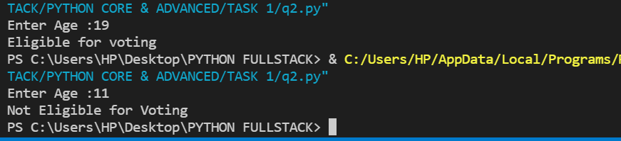

**Q3: Write a program to check the given number is odd or even**

**PROGRAM**

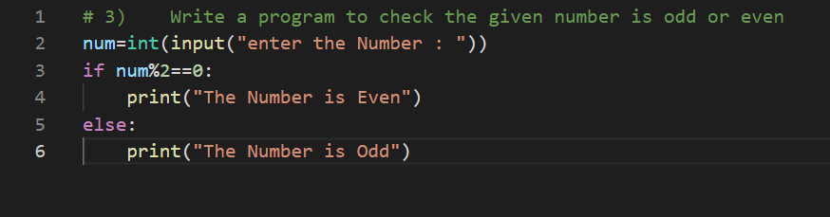

**OUTPUT**

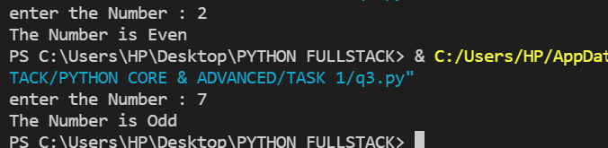

**Q4: Write a program for grade classification based on percentage   
conditions: percentage=90**

**grade A:-percentage in between 80-90**

**grade B:-percentage in between 70-80**

**grade C :-percentage less than 70**

**fail  
 PROGRAM**

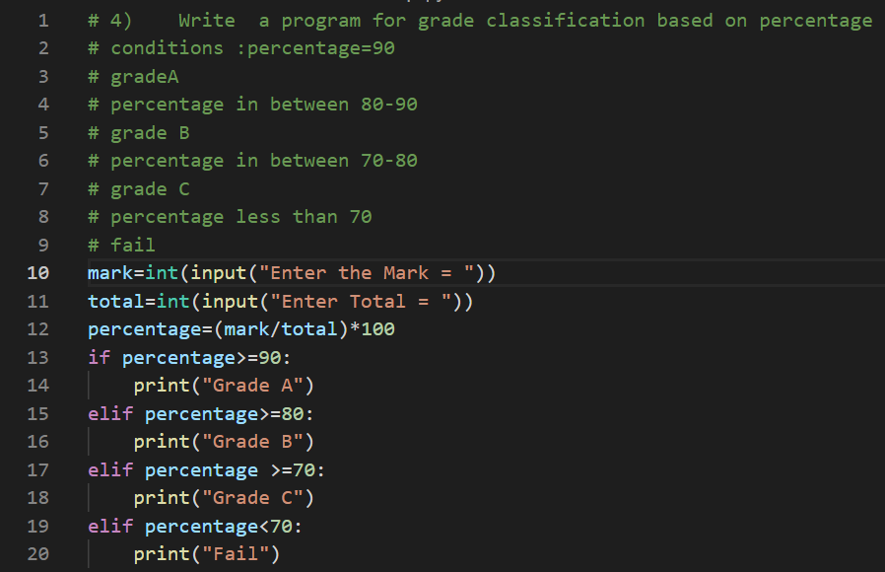

**OUTPUT**

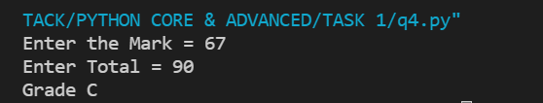

**Q5: Write a program to check the given year is a leap year or not**

**PROGRAM**

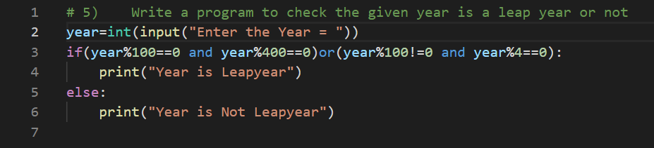

**OUTPUT**

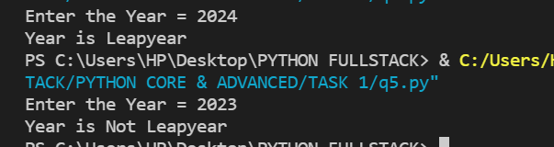

**Q6: Write a program to determine largest of three numbers**

**PROGRAM**

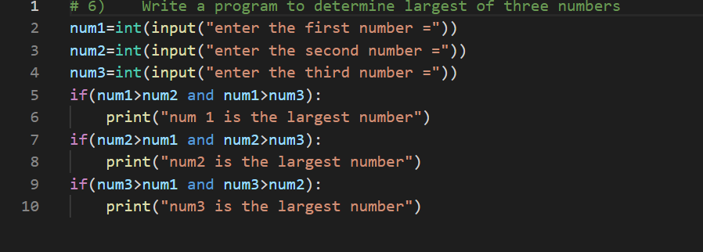

**OUTPUT**

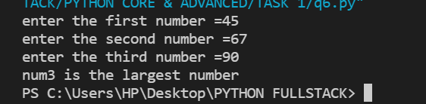

**Q7: Write program for a simple calculator**

**PROGRAM**

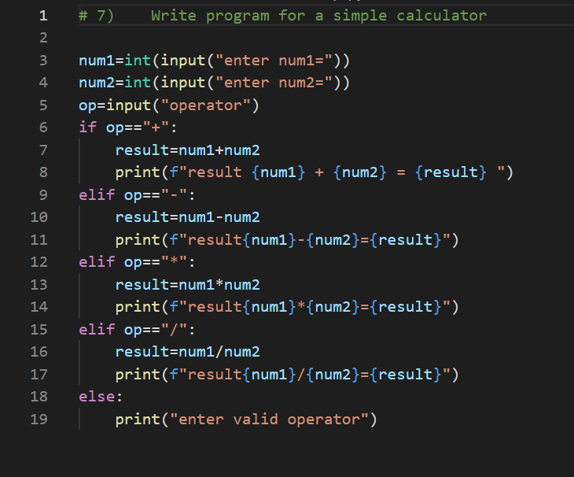

**OUTPUT**

